Computer Networks

Lab Task #11

Saad Ahmad

20P-0051

**Topology A:**

**Questions:**

1. Based on the topology, how many subnets are needed?

**5**

1. How many bits must be borrowed to support the number of subnets in the topology?

**3 bits**

1. How many subnets does this create?

**8 subnets**

1. How many usable hosts does this create per subnet?

**30 hosts**.

1. Calculate the binary value for the first five subnets. The first two subnets have been done for you.

|  |  |  |  |  |  |  |  |  |  |
| --- | --- | --- | --- | --- | --- | --- | --- | --- | --- |
| **Subnet** | **Network Address** | **Bit 7** | **Bit 6** | **Bit 5** | **Bit 4** | **Bit 3** | **Bit 2** | **Bit 1** | **Bit 0** |
| 0 | 192.168.100. | 0 | 0 | 0 | 0 | 0 | 0 | 0 | 0 |
| 1 | 192.168.100. | 0 | 0 | 1 | 0 | 0 | 0 | 0 | 0 |
| 2 | 192.168.100. | 0 | 1 | 0 | 0 | 0 | 0 | 0 | 0 |
| 3 | 192.168.100. | 0 | 1 | 1 | 0 | 0 | 0 | 0 | 0 |
| 4 | 192.168.100. | 1 | 0 | 0 | 0 | 0 | 0 | 0 | 0 |

1. Calculate the binary and decimal value of the new subnet mask.

|  |  |  |  |  |  |  |  |  |  |  |
| --- | --- | --- | --- | --- | --- | --- | --- | --- | --- | --- |
| **First Octet** | **Second Octet** | **Third Octet** | **Mask Bit 7** | **Mask Bit 6** | **Mask Bit 5** | **Mask Bit 4** | **Mask Bit 3** | **Mask Bit 2** | **Mask Bit 1** | **Mask Bit 0** |
| 11111111 | 11111111 | 11111111 | 1 | 1 | 1 | 0 | 0 | 0 | 0 | 0 |

|  |  |  |  |  |  |  |  |  |  |  |
| --- | --- | --- | --- | --- | --- | --- | --- | --- | --- | --- |
| **First Octet** | **Second Octet** | **Third Octet** | **Mask Bit 7** | **Mask Bit 6** | **Mask Bit 5** | **Mask Bit 4** | **Mask Bit 3** | **Mask Bit 2** | **Mask Bit 1** | **Mask Bit 0** |
| **First Decimal Octet** | **Second Decimal Octet** | **Third Decimal Octet** | **Fourth Decimal Octet** | | | | | | | |
| 255. | 255. | 255. | 224 | | | | | | | |

1. Fill in the **Subnet Table**, listing the decimal value of all available subnets, the first and last usable host address, and the broadcast address. Repeat until all addresses are listed.

|  |  |  |  |  |
| --- | --- | --- | --- | --- |
| **Subnet Number** | **Subnet Address** | **First Usable Host Address** | **Last Usable Host Address** | **Broadcast Address** |
| **0** | 192.168.100.0 | 192.168.100.1 | 192.168.100.30 | 192.168.100.31 |
| **1** | 192.168.100.32 | 192.168.100.33 | 192.168.100.62 | 192.168.100.63 |
| **2** | 192.168.100.64 | 192.168.100.65 | 192.168.100.94 | 192.168.100.95 |
| **3** | 192.168.100.96 | 192.168.100.97 | 192.168.100.126 | 192.168.100.127 |
| **4** | 192.168.100.128 | 192.168.100.129 | 192.168.100.158 | 192.168.100.159 |
| **5** | 192.168.100.160 | 192.168.100.161 | 192.168.100.190 | 192.168.100.191 |
| **6** | 192.168.100.192 | 192.168.100.193 | 192.168.100.222 | 192.168.100.223 |
| **7** | 192.168.100.224 | 192.168.100.225 | 192.168.100.254 | 192.168.100.255 |
| **8** |  |  |  |  |

**Step 2: Assign the subnets to the network shown in the topology.**

1. Assign Subnet 0 to the LAN connected to the GigabitEthernet 0/0 interface of R1:

192.168.100.0 /27

1. Assign Subnet 1 to the LAN connected to the GigabitEthernet 0/1 interface of R1:

192.168.100.32 /27

1. Assign Subnet 2 to the LAN connected to the GigabitEthernet 0/0 interface of R2:

192.168.100.64 /27

1. Assign Subnet 3 to the LAN connected to the GigabitEthernet 0/1 interface of R2:

192.168.100.96 /27

1. Assign Subnet 4 to the WAN link between R1 to R2:

192.168.100.128 /27

**Step 3: Document the addressing scheme.**

Fill in the **Addressing Table** using the following guidelines:

|  |  |  |  |  |
| --- | --- | --- | --- | --- |
| **Device e** | **Interface** | **IP Address** | **Subnet Mask** | **Default Gateway** |
| R1 | G0/0 | 192.168.100.1 | 255.255.255.224 | Nile |
| G0/1 | 192.168.100.33 | 255.255.255.224 | Nile |
| S0/0/0 | 192.168.100.129 | 255.255.255.224 | Nile |
| R2 | G0/0 | 192.168.100.65 | 255.255.255.224 | Nile |
| G0/1 | 192.168.100.97 | 255.255.255.224 | Nile |
| S0/0/0 | 192.168.100.130 | 255.255.255.224 | Nile |
| PC0 | Nile | 192.168.100.2 | 255.255.255.224 | 192.168.100.1 |
| PC1 | Nile | 192.168.100.34 | 255.255.255.224 | 192.168.100.33 |
| PC2 | Nile | 192.168.100.66 | 255.255.255.224 | 192.168.100.65 |
| PC3 | Nile | 192.168.100.98 | 255.255.255.224 | 192.168.100.97 |

**Part 2: Implement given topology in Packet Tracer and Assign IP Addresses to Network Devices and Verify Connectivity.**

Add 4x PCs, 4x Switches and 2x Routers and connect them

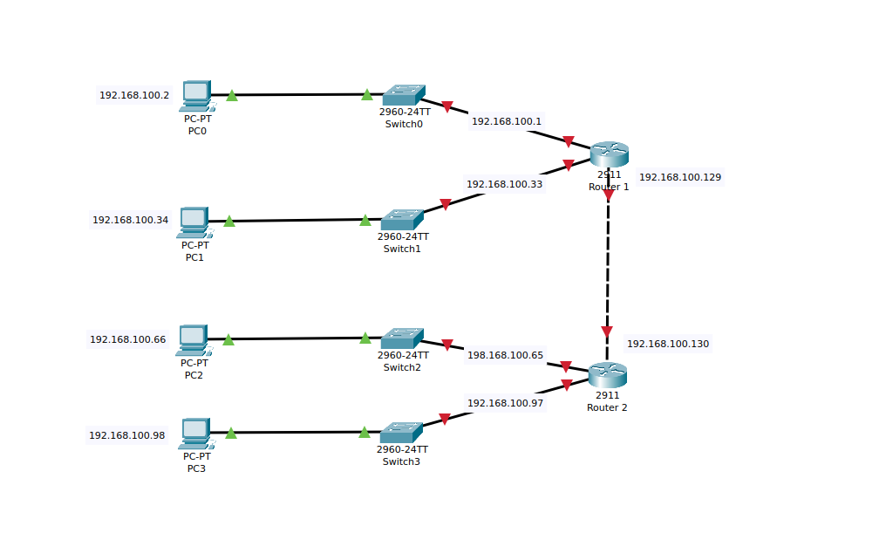

Now we will assign the IPs to the PCs

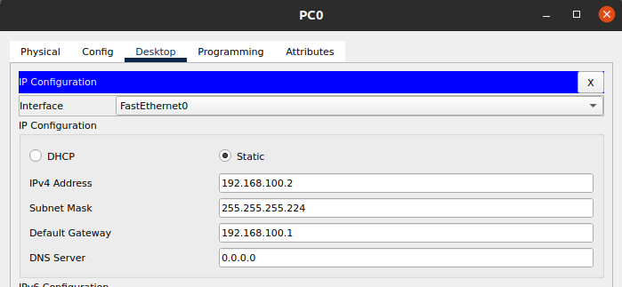

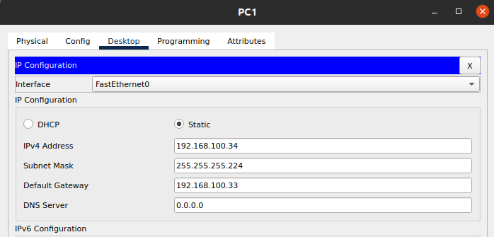

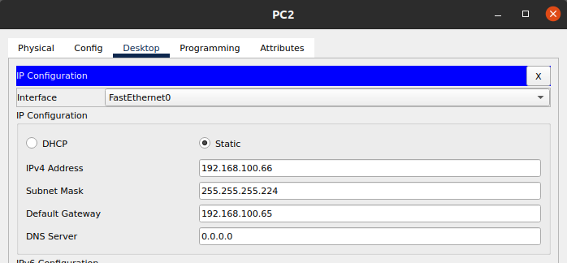

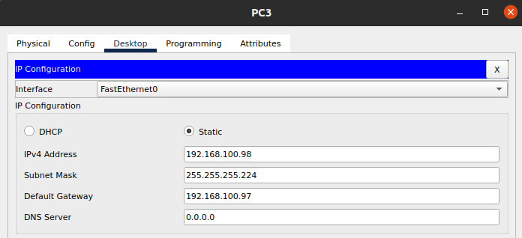

And now we will configure the routes

**Router# 1**

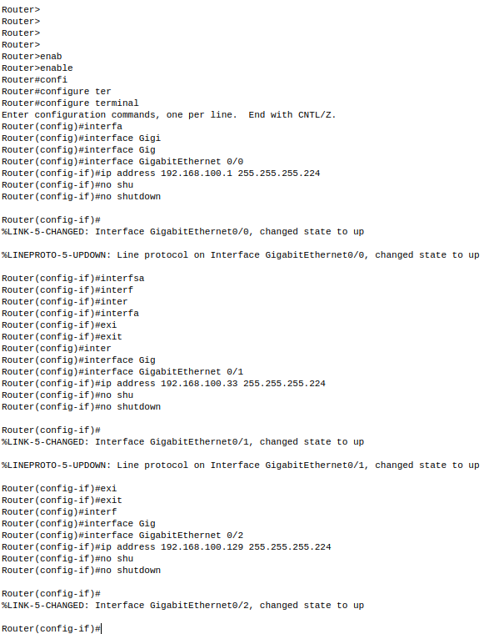

**Router# 2**

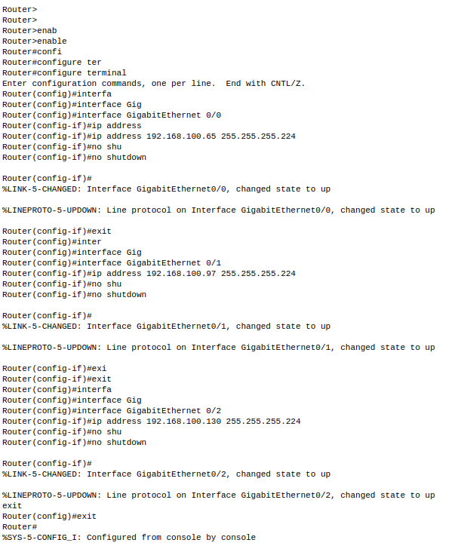

And now we will configure the static IPs

**Router# 1**

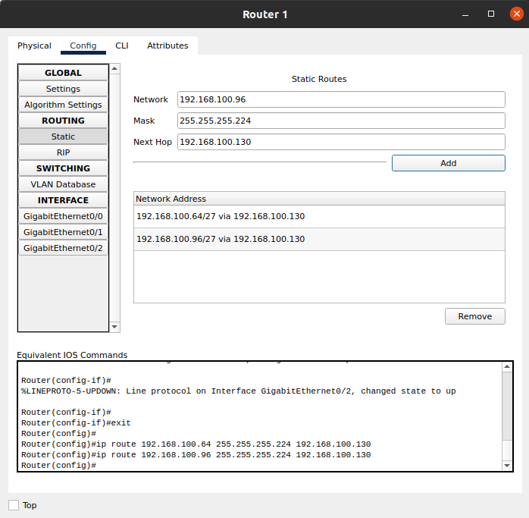

**Router# 2**

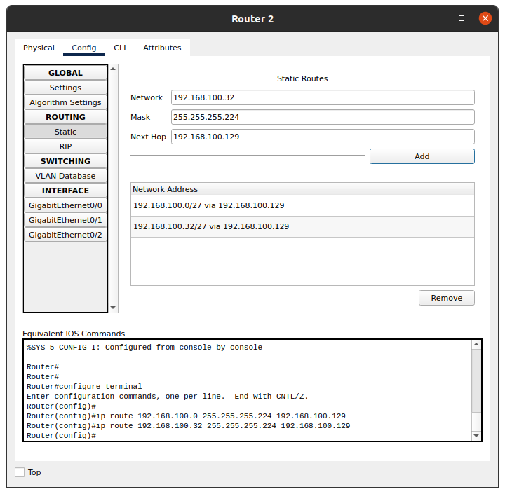

Verifying the connection between the PCs

**Form PC0**

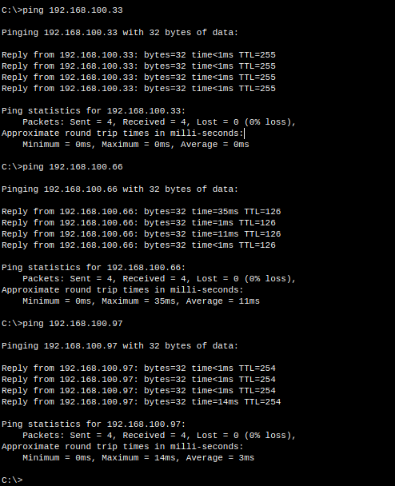

**From PC2**

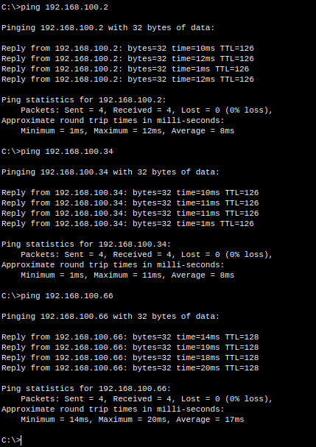

**Topology B:**

Add 6x PCs, 3x Switches, 3x Routers and connect them.

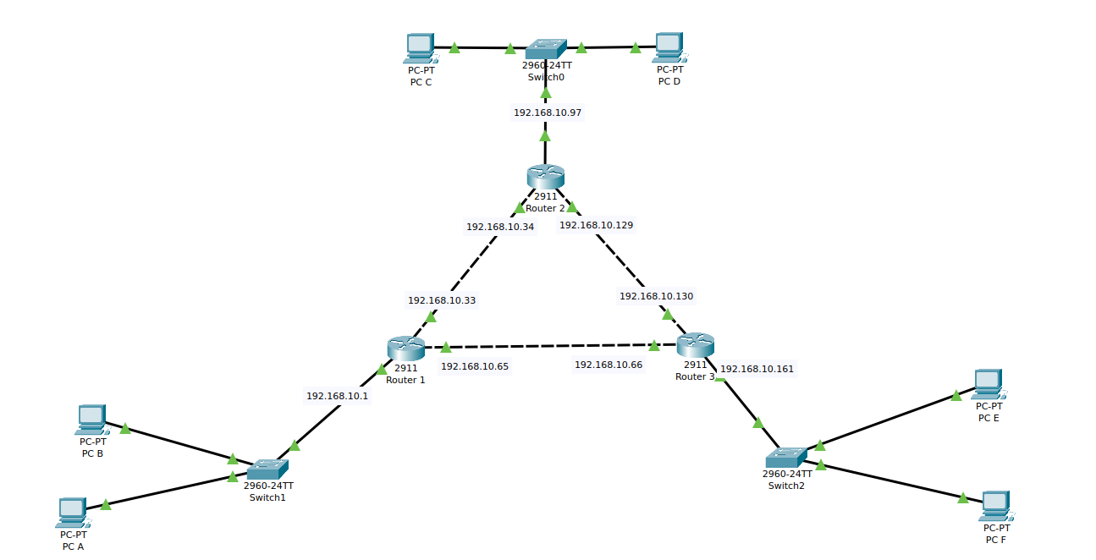

Now we will assign the IPs to the PCs

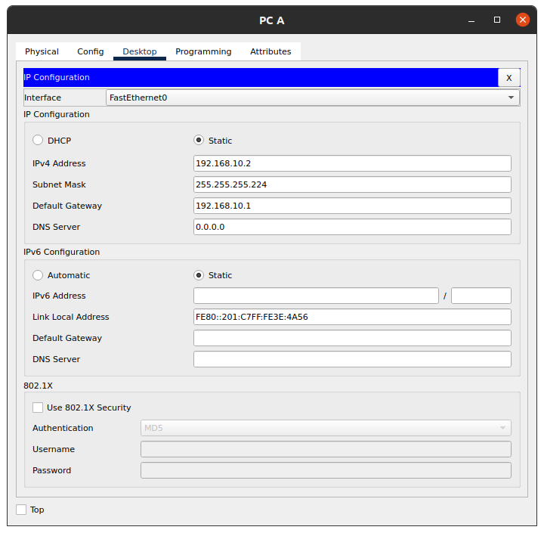

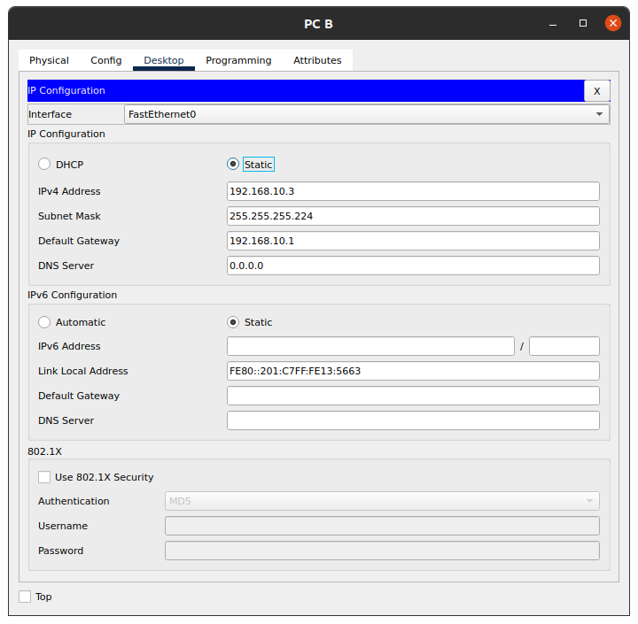

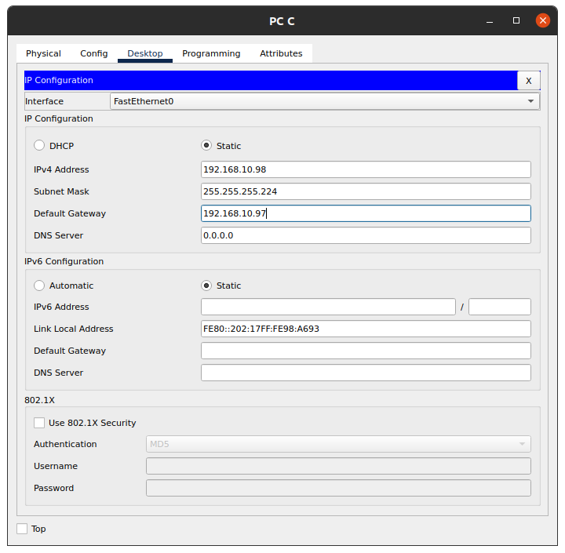

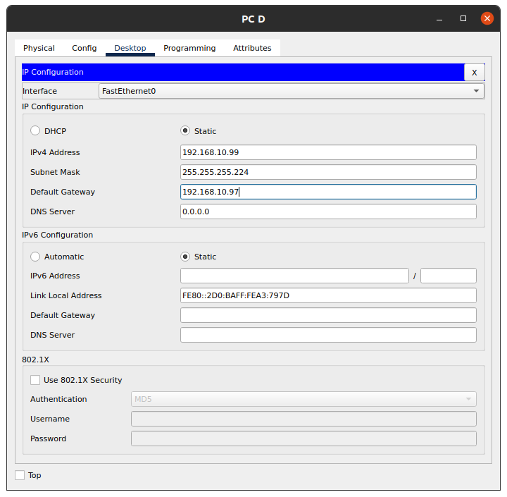

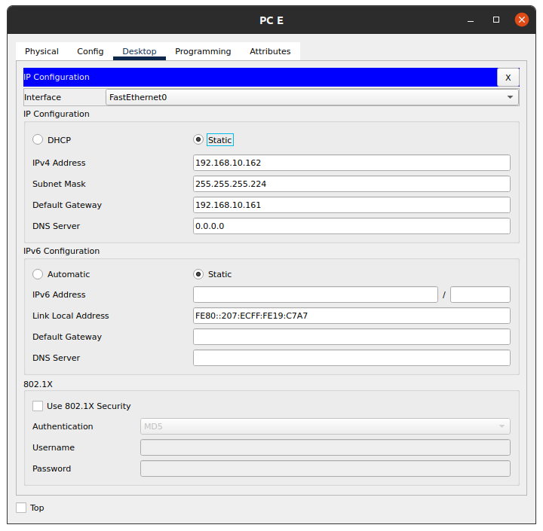

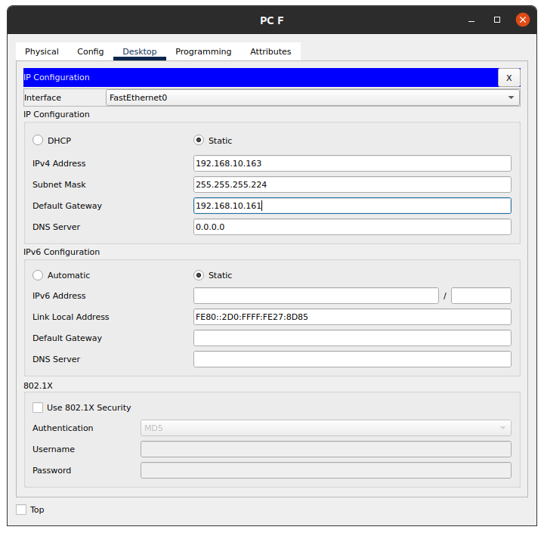

And now we will configure the Routers

**Router#1**

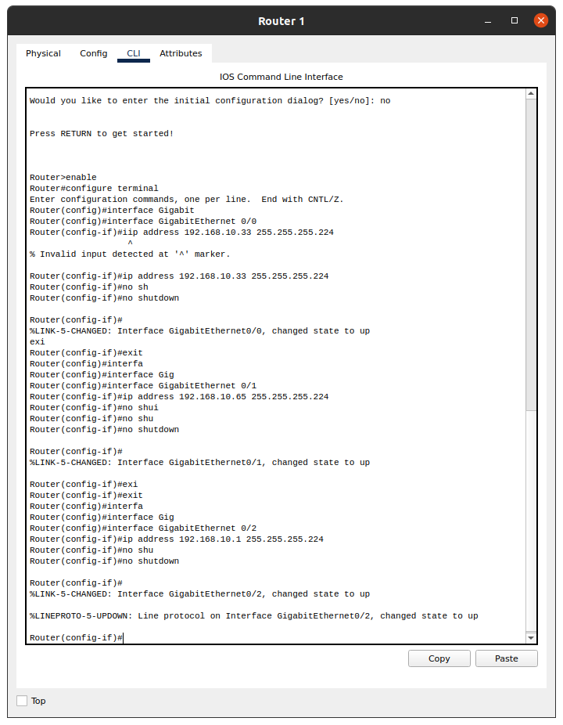

**Router#2**

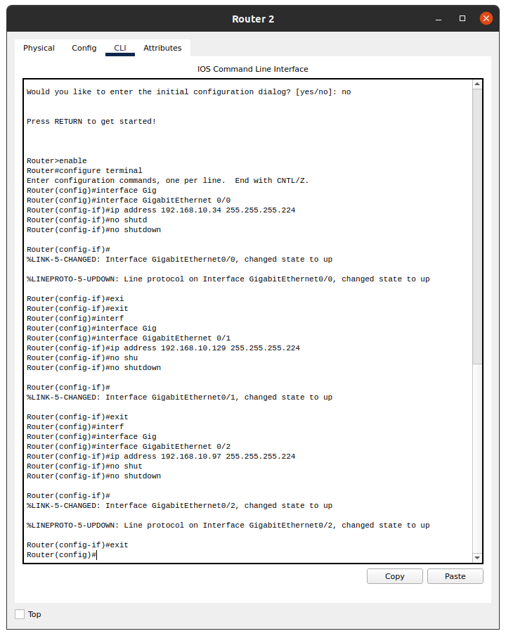

**Router#3**

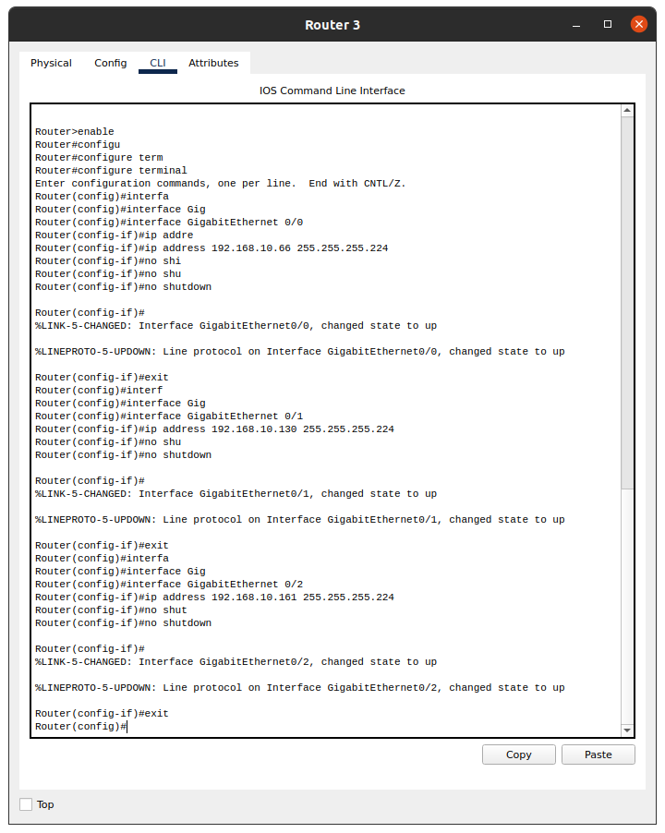

And now we will do the static routing on each router

**Router#1**

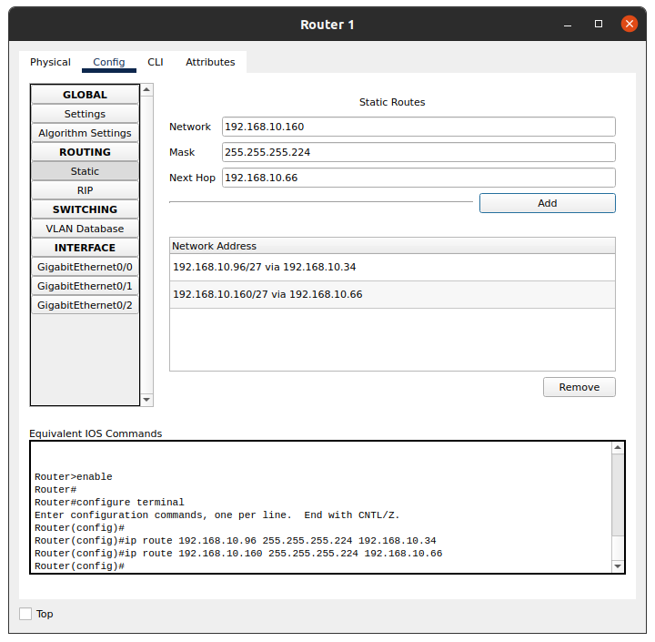

**Router#2**

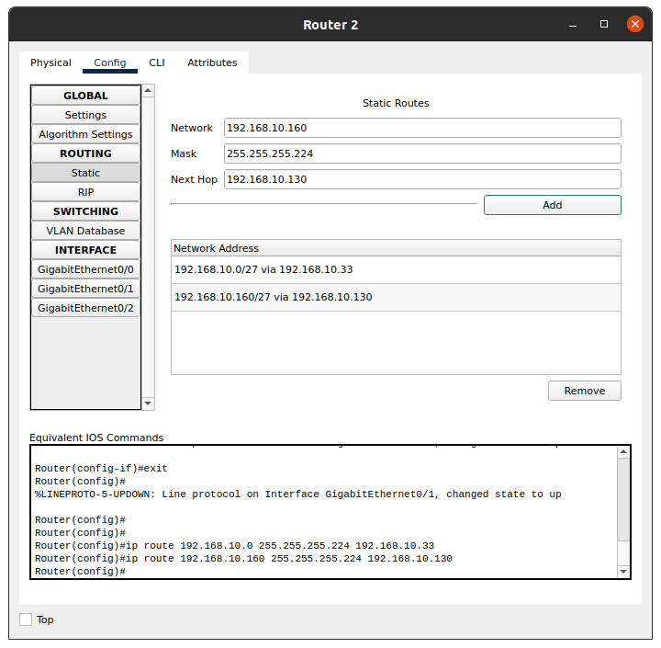

**Router#3**

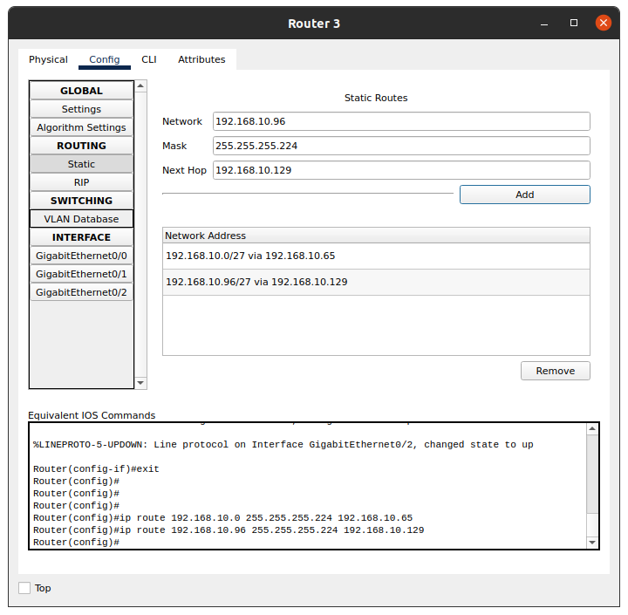

Checking the connection between the PCs on different networks

**Form PC#B**

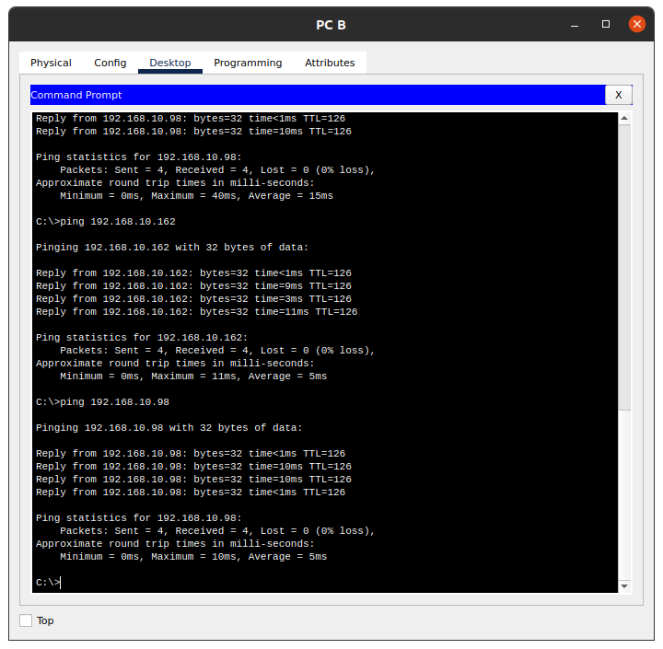

**From PC#D**

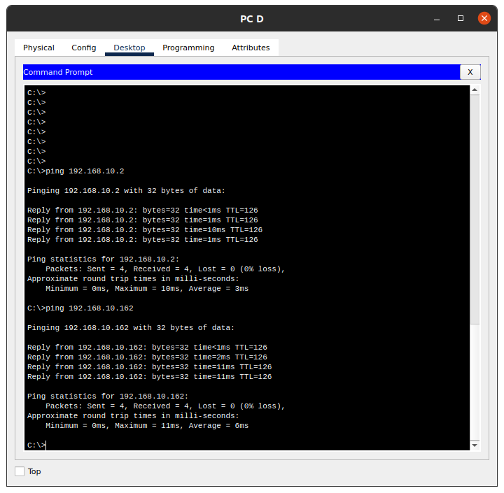

**From PC#F**

